Calculations

This document contains a number of formulas used with surface plasmon resonance and biomolecular interaction analysis. For the convenience of the reader, an Excel spreadsheet (BiaCalculations.xlsm) is available on www.sprpages.nl that facilitates the use of these formulas.

The abbreviations used in the formulas are:

Name Meaning
Da Dalton
RU response units
M Molar
Mr molecular mass in Da
R response in RU
Req equilibrium response in RU
Rmax maximal response in RU
k_{a} association rate constant in M⁻¹s⁻¹
k_{d} dissociation rate constant in s⁻¹
K_{D} equilibrium constant in M
D diffusion constant in m²s⁻¹

The units used in the formulas are:

Symbol Name SI units
N Newton kg m s⁻²
Pa Pascal N m⁻²
J Joule N m
Liquid viscosity Poise = Pa s

The constants used in the formulas are:

Symbol Name SI units
N_{A} constant of Avogadro 6.0220 10²³ mol⁻¹
R Gas constant 8.3144 J mol⁻¹ K⁻¹
k constant of Boltzmann 1.3807 10⁻²³ J K⁻¹
h constant of Planck 6.6262 10⁻³⁴ J s
c speed of light (vacuum) 2.9979 10⁸ m s⁻¹

Each worksheet is divided in two parts:
(yellow) input of data
(orange) output of calculations

Please note that in order to obtain useful results, the input values should be in the correct units (as indicated per input cell).

Conversions

Response to concentration conversion
The surface concentration Gamma (G), for a protein can be calculated by the following formula (3). One Response Unit (RU) in the Biacore 2000/3000 machine corresponds to a surface coverage of 10⁻⁶ g m⁻² for a typical protein. A 100 kDa protein generating a response of 1000 RU, corresponds to a surface coverage of 10⁻⁸ moles m⁻².

Formulas
(mole.m⁻²)

Input
Response | 500 | RU
Molecular mass | 60000 | Da
Calculated
Binding sites | 0.0083 | pmol mm⁻²
Binding sites | 8.3E-09 | mol m⁻²
Surface density | 0.5 | ng mm⁻²
Surface density | 0.0005 | g m⁻²
Concentration | 8.3E-05 | mol L⁻¹
Concentration | 5 | mg mL⁻¹

Concentration calculation

Calculate molar concentrations based on mg mL⁻¹ and molecular mass and calculate dilutions.

 | Stock concentration
Protein | mg mL⁻¹ | Da | M | µM
A | 2.7 | 150000 | 1.80E-05 | 18.00
B | 4.66 | 150000 | 3.11E-05 | 31.07
 | Pre dilutions
 | stock | volume | end vol. | conc
 | µM | µL | µL | nM
A | 18.00 | 10 | 720.0 | 250
B | 31.07 | 10 | 310.7 | 1000

Use this table to calculate the concentration of small compounds when dissolving small quantities in small volumes.

compound | amount | Mw | amount | conc | volume | conc
 | gram | Da | Mol | M | ml | M
T101 | 0.005 | 248.77 | 2.01E-05 | 2.01E-05 | 0.5 | 4.02E-02

Calculating immobilization
The table calculates the amount of ligand to immobilize to obtain a theoretical analyte response. In general, a R_{max} of 50 – 100 RU when the analyte is injected is sufficient (6). Immobilization of too much ligand can lead to mass transfer limitation and non-Langmuirian kinetics due to steric hindrance (4, 8).

Formula
(RU)

Ligand
Molecular mass | 60000 | Da
Valency | 1
Activity | 100 | %
Analyte
Molecular mass | 2000 | Da
Desired Rmax | 100 | RU
Calculations
Ligand immobilization | 3000 | RU
Ligand sites | 0.05000 | pmol mm⁻²

Calculations after immobilization
The table calculates some parameters after immobilization of the ligand and injection of the analyte. The theoretical R_{max} is calculated based on the molecular mass and amount of immobilized ligand and the molecular mass of the analyte. The same is done for the ligand sites and concentration. The amount of functional ligand (the ligand that is binding the analyte) is calculated on the basis of the measured Rmax (2).

Formulas
(RU)
(pmol.mm⁻²)
(mol.L⁻¹)
(%)

Ligand
Molecular mass | 40000 | Da
Immobilization | 111 | RU
Valency | 1
Analyte
Molecular mass | 92000 | Da
Rmax | 49 | Da
Calculations
Rmax analyte | 255 | RU
Ligand sites | 0.002775 | pmol/mm²
Ligand concentration | 2.78E-05 | mol/L
Ligand activity | 19.2 | %

Flow and Flow cell

Flow rate
The table converts the flow rate (μl/min) in different units.

Formulas
(l.s⁻¹)
(m³.s⁻¹)

Flow rate | f | 25 | μL.min⁻¹
Flow rate |  | 4.17E-07 | L.s⁻¹
Flow rate |  | 4.17E-10 | m³ s⁻¹

Flow cell
The table calculates the volume of the flow cell and the refresh rate.

Formulas
(m³)
(s⁻¹)

Flow rate | f | 3 | µL min⁻¹ | 5.00E-11 | m³s⁻¹
Height | h | 0.05 | mm | 5.00E-05 | m
Width | w | 0.3 | mm | 3.00E-04 | m
Length | l | 0.8 | mm | 8.00E-04 | m
Volume | v | 1.20E-02 | mm³ | 1.20E-11 | m³
Refresh rate |  | 250 | times per min⁻¹ | 4.2 | times per s⁻¹

Thickness of diffusion layer
The table calculates the thickness of the diffusion layer on basis of the diffusion coefficient (see below), flow cell dimensions and flow rate (5).

Formula
(m)

Diffusion coefficient | D | 5.00E-11 | m²s⁻¹ | 5.00E-11 | m²s⁻¹
Flow rate | f | 3 | μl min⁻¹ | 5.00E-11 | m³s⁻¹
Height | h | 0.05 | mm | 5.00E-05 | m
Width | w | 0.3 | mm | 3.00E-04 | m
Length | l | 0.8 | mm | 8.00E-04 | m
Thickness | d | 8.4 | µm | 8.43E-06 | m

Time shift between flow cells
The table calculates the time delay between flow cells of the Biacore 1000, 2000 and 3000 machines.

Formula
(s)

Flow rate | f | 10 | μl min⁻¹
Flow cell volume | v | 0.3 | μl min⁻¹
Shift |  | 1.8 | s

Wall shear
The table calculates wall shear based on the flow rate and a constant.

Formula
$q=\text{jw}⋅0\text{.}\text{0121}$ (ul.min⁻¹)

Flow rate | q | 25 | μl min⁻¹
Wall shear | jw | 2066 | s-1
Constant | f | 0.0121

Diffusion

Diffusion factor for globular proteins

The diffusion coefficient (D) for a globular protein can be approximated by the formula below (3). The f/fo is the friction factor and can be set to 1.2 if unknown. For proteins with an increasing degree of asymmetry (less globular), this value will become larger. The v/vo is the viscosity of the solution relative to water of 20°C. For water, the value is 0.89.

Formula
(m².s⁻¹)

Molecular mass | Mr | 50000 | Da
Friction factor | f/fo | 1.2
Solution viscosity | v/vo | 0.89
Factor 1 |  | 1.00E-11
Factor 2 |  | 324.3
Diffusion factor | D | 8.27E-11 | m²s⁻¹

Mass transport coefficient (km)

Diffusion factor | D | 6.94E-11 | m² s⁻¹
flow rate | f | 5.00E-11 | m/s
flow cell height | h | 5.00E-05 | m
flow cell width | w | 3.00E-04 | m
flow cell length | l | 8.00E-04 | m
factor 1 |  | 0.3
factor 2 |  | 0.98
k_{m} |  | 1.0803E-05 | m s⁻¹

Mass transport coefficient (kt)

k_{m} |  | 1.08E-05 | m s⁻¹
Molecular weight | Mr | 66500 | Da
Factor |  | 1.00E+09
k_{t} |  | 7.18E+08 | RU M⁻¹ s⁻¹

Dynamic viscosity of water

 | A | 2.41E-05 | Pa.s
 | B | 247.8 | K
 | C | 140 | K
 | T | 298 | K
 | v | 8.93E-04 | Pa.s

The dynamic viscosity of water is 8.90 × 10−4 Pa·s or 8.90 × 10−3 dyn·s/cm2 or 0.890 cP at about 25 °C.
Water has a viscosity of 0.0091 poise at 25 °C, or 1 centipoise at 20 °C.
As a function of temperature T (K): (Pa·s) = A × 10B/(T−C)
where A=2.414 × 10−5 Pa·s ; B = 247.8 K ; and C = 140 K.[citation needed]

Dilution
Use the dilution table to calculate minimal injection volumes and dilution steps.
Start with the flow rate, injection time and replicates.
Then transport the total volume value to the final volume (you can adjust the final volume).
Adjust the dilution step, highest desired analyte concentration and stock concentration.
In the dilution scheme, the dilutions are given.
In addition, some parameters are calculated from the input of the k_{a}, k_{d} and solvent values. The column under Req (%) lists the Req value in percentage of Rmax which can be reached when the injection time is long enough. The values are green when the fall in the range of 10 – 90% Rmax.

Simple dilution wizard (one vial per dilution).

 | Biacore 2000/3000 | T100/200
Inject command | KInject | Inject |  | Protein
Flow rate | 30 | 30 | ul/min | Dilution step |  | 2 | x
Inject time | 2 | 2 | 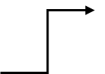  min | Final volume |  | 200 | µL
Replicates | 2 | 2 | x | Highest conc. |  | 1000 | nM
Extra volume | 40 | 40 | ul | Stock concentration |  | 8642 | nM
Total volume | 200 | 200 | ul

 | Stock |  | buffer | mix | Final solution |  | K_{D} | Req | Solvent
Vial | (nM) | (µL) | (µL) | (µL) | (nM) | (µL) | (x) | (%) | (%)
1 | 8642.00 | 46.29 | 353.7 | 400.0 | 1000.00 | 200.0 | 10.00 | 91 | 11.571
2 | 1000.00 | 200.0 | 200.0 | 400.0 | 500.00 | 200.0 | 5.00 | 83 | 5.786
3 | 500.00 | 200.0 | 200.0 | 400.0 | 250.00 | 200.0 | 2.50 | 71 | 2.893
4 | 250.00 | 200.0 | 200.0 | 400.0 | 125.00 | 200.0 | 1.25 | 56 | 1.446
5 | 125.00 | 200.0 | 200.0 | 400.0 | 62.50 | 200.0 | 0.63 | 38 | 0.723
6 | 62.50 | 200.0 | 200.0 | 400.0 | 31.25 | 200.0 | 0.31 | 24 | 0.362
7 | 31.25 | 200.0 | 200.0 | 400.0 | 15.63 | 200.0 | 0.16 | 14 | 0.181
8 | 15.63 | 200.0 | 200.0 | 400.0 | 7.81 | 200.0 | 0.08 | 7 | 0.090
9 | 7.81 | 200.0 | 200.0 | 400.0 | 3.91 | 200.0 | 0.04 | 4 | 0.045
10 | 3.91 | 200.0 | 200.0 | 400.0 | 1.95 | 400.0 | 0.02 | 2 | 0.023

Dilution wizard with duplo sample.
This wizard is designed to give a duplo sample for the second highest concentration.

Dilution wizard for competition experiments.
Use this wizard to make samples with a constant concentration of analyte and a titration of competitor.
Don’t forget to make a sample without competitor.

Equilibrium

Theoretical Req
The table calculates the theoretical Req on basis of the association and dissociation constants and the analyte concentration. Input of (calculated) values from the first analyte injection can provide estimates of the range of concentrations needed for the future experiments. The Rmax is included to visualize the actual data. The column with ‘x KD’ shows the relation between K_{D} and the analyte concentration.
The analyte concentrations come from the dilution page.

Formulas

k_{a} | 1.00E+06 | M⁻¹s⁻¹
k_{d} | 1.00E-02 | s⁻¹
Rmax | 100 | RU
Rmax | 95 | %

C | C | KD | Rmax | Rmax
(M) | (nM) | (x) | (RU) | (%)
1.00E-06 | 1000.00 | 100.000 | 99 | 99
5.00E-07 | 500.00 | 50.000 | 98 | 98
2.50E-07 | 250.00 | 25.000 | 96 | 96
1.25E-07 | 125.00 | 12.500 | 93 | 93
6.25E-08 | 62.50 | 6.250 | 86 | 86
3.13E-08 | 31.25 | 3.125 | 76 | 76
1.56E-08 | 15.63 | 1.563 | 61 | 61
7.81E-09 | 7.81 | 0.781 | 44 | 44
3.91E-09 | 3.91 | 0.391 | 28 | 28
1.95E-09 | 1.95 | 0.195 | 16 | 16

Time to equilibrium
The table calculates the time to reach equilibrium based on the association and dissociation constants and the analyte concentration. The percentage of Req to reach is set to 95% of the Rmax. This can be adjusted at the kinetics input.

Formulas
(s)

k_{a} | 1.00E+06 | M⁻¹s⁻¹
k_{d} | 1.00E-02 | s⁻¹
Rmax | 100 | RU
Rmax | 95 | %

C | Time | Time | Time
(M) | (s) | (min) | (hour)
1.00E-06 | 3 | 0 | 0.0
5.00E-07 | 6 | 0 | 0.0
2.50E-07 | 12 | 0 | 0.0
1.25E-07 | 22 | 0 | 0.0
6.25E-08 | 41 | 1 | 0.0
3.13E-08 | 73 | 1 | 0.0
1.56E-08 | 117 | 2 | 0.0
7.81E-09 | 168 | 3 | 0.0
3.91E-09 | 215 | 4 | 0.1
1.95E-09 | 251 | 4 | 0.1

Complex half-life
The table calculates the time to dissociate to half the starting value. The complex half-life depends only on the dissociation constant (1). As a rule of thumb, the dissociation curve should decrease at least 5% before analysis can be attempted (7).

Formula
$t_{12}=\frac{\text{ln}2}{k_{d}}$ (s⁻¹)

kd | t1/2 | t1/2 | t1/2
(s-1) | (s) | (min) | (hour)
1.00E-01 | 7 | 0.1 | 0.0
1.00E-02 | 69 | 1.2 | 0.0
1.00E-03 | 693 | 11.6 | 0.2
1.00E-04 | 6931 | 115.5 | 1.9
1.00E-05 | 69315 | 1155.2 | 19.3
1.00E-06 | 693147 | 11552.5 | 192.5

Time to 5% dissociation
Formula

kd | t | t | t
(s-1) | (s) | (min) | (hour)
1.00E-01 | 1 | 0.0 | 0.0
1.00E-02 | 5 | 0.1 | 0.0
1.00E-03 | 51 | 0.9 | 0.0
1.00E-04 | 513 | 8.5 | 0.1
1.00E-05 | 5129 | 85.5 | 1.4
1.00E-06 | 51290 | 854.8 | 14.2

Time to 95% dissociation
Formula

kd | Time | Time
(s-1) | (min) | (hour)
1.00E-01 | 0.5 | 0.0
1.00E-02 | 5.0 | 0.1
1.00E-03 | 49.9 | 0.8
1.00E-04 | 499.3 | 8.3
1.00E-05 | 4992.9 | 83.2
1.00E-06 | 49928.9 | 832.1

Complex calculation
Use this page to calculate the complex in free solution.
Notice that there are three conditions that give a different complex calculation.
This page is still in the experimental state.

Solvent calibration
Calculate the best dilution to perform the solvent calibration.
 | Solvent
 | Solvent stock |  | 10 | (%)
 | no. Dilutions |  | 6
 | Lowest |  | 2 | (%)
 | Highest |  | 6 | (%)
 | Volume |  | 500 | (µl)
 | Solvent calibration solutions |  |  |  | Calibration response levels
 | Solvent | Buffer | Volume | Conc. | Reference | Active | Correction
 | (µl) | (µl) | (µl) | (%) | (RU) | (RU) | (RU)
1 | 100 | 400 | 500 | 2.00 | -515 | -487 | 28
2 | 140 | 360 | 500 | 2.80 | -285 | -265 | 20
3 | 180 | 320 | 500 | 3.60 | -85 | -77 | 8
4 | 220 | 280 | 500 | 4.40 | 171 | 169 | -2
5 | 260 | 240 | 500 | 5.20 | 442 | 428 | -14
6 | 300 | 200 | 500 | 6.00 | 642 | 617 | -25
7 | 340 | 160 | 500 | 6.80 | 908 | 870 | -38
8 | 380 | 120 | 500 | 7.60 | 1085 | 1038 | -47
9 | 420 | 80 | 500 | 8.40 |  |  | 0
10 | 460 | 40 | 500 | 9.20 |  |  | 0

Simulation
A simulation of the association and dissociation in Excel.
 | Rt1 | Rt2 | Rt3 | Rt4
Rmax | 100 | 100 | 100 | 100
k_{a} | 1.00E+05 | 1.00E+05 | 1.00E+05 | 1.00E+05 | M⁻¹s⁻¹
C | 1.25E-08 | 2.50E-08 | 5.00E-08 | 1.00E-07 | M
k_{d} | 1.00E-02 | 1.00E-02 | 1.00E-02 | 1.00E-02 | s⁻¹
Req | 11 | 20 | 33 | 50
k_{a}*C+k_{d} | 1.13E-02 | 1.25E-02 | 1.50E-02 | 2.00E-02
K_{D} | 1.00E-07 | 1.00E-07 | 1.00E-07 | 1.00E-07 | M
C (x K_{D}) | 0.1 | 0.3 | 0.5 | 1.0 | x
t_{max} | 400 | 400 | 400 | 400 | s
R at t_{max} | 11.0 | 19.9 | 33.3 | 50.0 | RU
% of Req | 98.9 | 99.3 | 99.8 | 100.0 | %
% of Rmax | 11.0 | 19.9 | 33.3 | 50.0 | %

Kinetic plot
Create a kinetic plot in Excel by adding the values in the table.

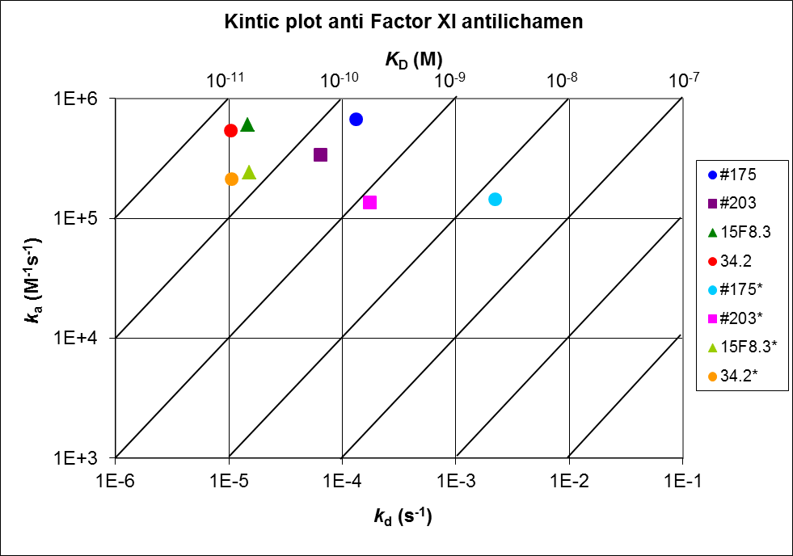

References
1. BIACORE AB; Kinetic and affinity analysis using BIA - Level 1. 1997.
2. BIACORE AB; BIACORE Technology Handbook; 1998.
3. BIACORE AB; BiaSimulation. 1998.
4. Edwards, P. R. and Leatherbarrow, R. J.; Determination of association rate constants by an optical biosensor using initial rate analysis. Anal.Biochem. (246): 1-6; 1997.
5. Glaser, R. W.; Antigen-antibody binding and mass transport by convection and diffusion to a surface: a two-dimensional computer model of binding and dissociation kinetics. Anal.Biochem. (213): 152-161; 1993.
6. Karlsson, R., Michaelson, A, and Mattson, L; Kinetic analysis of monoclonal antibody-antigen interactions with a new biosensor based analytical system. J.Immunol.Methods 229-240; 1991.
7. Katsamba, P. S. et al; Kinetic analysis of a high-affinity antibody/antigen interaction performed by multiple Biacore users. Anal.Biochem. (352): 208-221; 2006.
8. O'Shannessy, D. J. and Winzor, D. J.; Interpretation of deviations from pseudo-first-order kinetic behavior in the characterization of ligand binding by biosensor technology. Anal.Biochem. (236): 275-283; 1996.

Disclaimer

This document is compiled from the publications mentioned in the reference list and my own research. The document is provided as is in a good scientific manner to share knowledge. There is no warranty that the content is accurate or up to date.

You may use this document for your own research purposes. You may copy the document as long as you keep it intact. It is not allowed to use this document or parts of it for commercial purposes.

For more information go to the SPR Pages at www.sprpages.nl

